An alternator creates an alternative current. Nevertheless, to charge a phone, we need a direct one. Our electric circuit’s goal will be to transform this current.

After a few internet searches, we found the following circuit :
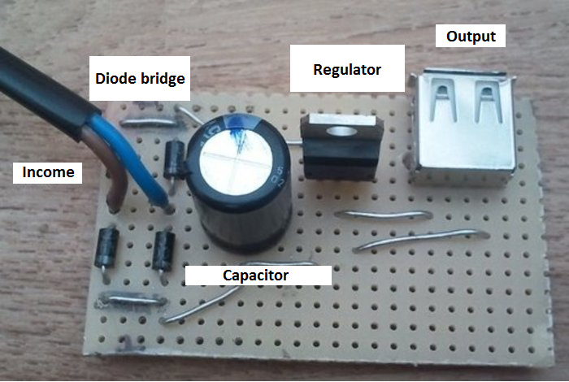

We will need all those components, in order to build our own circuit. We will also need an old bike and a box to put the circuit in safety.

The main objectif is the transformation of the current, so the first step is, with the diode bridge, clear the negative part of the current to transform on an only positive current. All this success thanks to the diode bridge’s proprieties which let past the current only on one way.

After the diode bridge it’s the turn of the capacitor and the regulator to play. They will smooth the current in order to

